
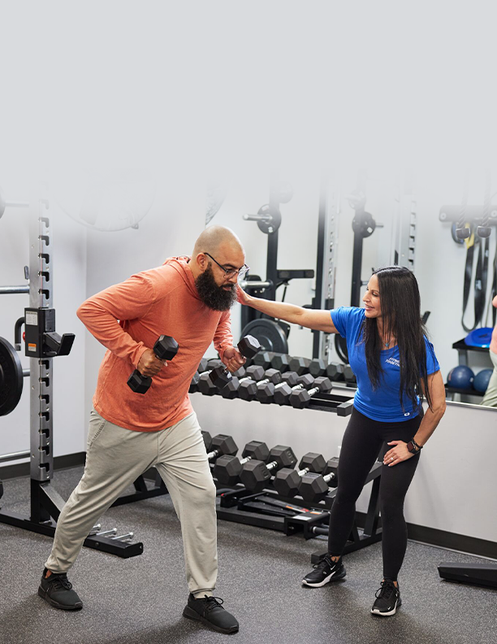

TEMPLATE
First Visit Report Workbook
for Fitness Businesses

(Your Business Name)
First Visit Report Workbook

Your fitness business welcomes new faces every week—especially if you take advantage of ClassPass. When new visitors come to your studio, they’re greeted warmly by your front desk, introduced to their instructor, and given a stellar workout. They leave sweaty and smiling, filled with the endorphins only a great class can provide.

You’ve created the perfect client experience. Now what?

Multiple touchpoints (phone call, text, email, or in-person conversation) are necessary for a buyer—or in this case, a new client—to commit. If your team isn’t following up with every first-time visitor, you’re missing out on key opportunities to increase both memberships and revenue.

Ready to turn those 1st time visitors into 500th time visitors? This workbook is designed to do just that.

But first, review your First Visit Report

How well are you retaining first-time visitors now? Let’s look at the numbers.

If you’re a Mindbody customer:
- Log into the software
- Click Reports in the upper right corner
- Click Client > Visits & Retention > First Visit (or search First Visit)
- Select dates (Choose dates at least 2-3 months in the past)
- Choose the Service Category you want to analyze (start with your biggest category)
- Click Tag New to see the unique number of first-time visitors during this time frame
- Record the number of tagged clients

- Change the end date to be the end of the most recent month
- Under Filters, check:
  - Show tagged clients only
  - Only show clients with no visits after the first visit
  - Click Go!
  - Go to the bottom left to find the number of those who didn’t return

- Divide the two numbers to get a %

Consider your current follow-up process

How do you keep track of first-time visitors (aka new leads)? Do you run reports and use sticky notes, a spreadsheet, etc.? Jot down your system(s) below.

How do you check in with first-time visitors after class (e.g., text, email, phone call, in-person conversation)? Write down all touchpoints below.

If you use text or email, how do you communicate in a way that’s true to your brand? Add (or draft) your follow-up text(s) and/or email(s) below. We've included examples.

Follow-up text(s):

How to write a great follow-up text:
- Personalize the message
- Use your brand voice (which may or may not include the use of emojis)
- Say thanks
- Include a question to prompt a response

Example: Hi [client name] 👋 Thank you so much for sweating with us at [business name] today! How was your first workout?

Example: We hope you had a great first class at [business name], [client name]! Thanks so much for stopping in! When will we see you again?

Example: You crushed your first [business name] class, [client name]! Ready to take advantage of our new client special and get your second one scheduled?

Follow-up email(s)

How to write a great follow-up email:
- Personalize the message
- Use your brand voice
- Link out to your website for more information
- Add a CTA

Example: Thanks so much for coming to [business name], [client]! We hope you're feeling energized and strong!

If you’re ready for more, our new client special is the way to go. It includes [details of new client special] for [price].
CTA: Buy it now!

Optimize your approach

How much time and effort does it currently take to keep tabs on new visitors? Do you use sticky notes and spreadsheets? Do you have a staff member dedicated to keeping track of your sales pipeline? How many hours are spent each week/month managing this process (if at all)? Calculate below.

Consider how much time your follow-up touchpoints take. Do you have a staff member dedicated to reaching out via text/email/phone call? How many hours are spent on follow-ups each week/month (if at all)? How much does that cost you in payroll? Calculate below.

What if you could save time, money, and hassle, while also improving first-time visitor retention? Automation can help. Here’s how:

- With Lead Management, it’s simple to manage new leads with the integrated dashboard. Get access to insights about your sales process to identify—and fix—any gaps you might have.
- With Messenger^{[AI]}, an AI assistant, every prospective customer is followed up with after class via text—automatically. It answers questions and sells packages and memberships, too. That way, your staff stays focused on interactions in the studio while Messenger^{[AI]} handles the rest.
- With Marketing Suite, you can send additional email follow-ups to ensure your new client feels well cared for. Pro tip: Offer helpful post-class tips, reiterate the benefits of your new client trial, and make it easy to click through and purchase. Marketing Suite and Messenger^{[AI]} work together to create a seamless experience for all. No new client left behind!

Mindbody has everything you need to make running your fitness business feel simpler, and more efficient. and achieve your goals. Head to https://www.mindbodyonline.com/fitness/ to find out more.

This document is to be used for informational purposes only and does not constitute legal, business, or tax advice. Each person should consult his or her own attorney, business advisor, or tax advisor with respect to matters referenced in this template. Mindbody assumes no liability for actions taken in reliance upon the information contained herein. ©Mindbody 2022

